How to Generate synthetic data in Oracle DB 23 ai
Synthetic, or artificially generated, data can have many of the characteristics of real data and can be a powerful tool when developing and testing solutions, especially when actual data doesn’t yet exist or isn’t allowed to be used. Synthetic data is typically created using random generators, algorithms, or statistical models to simulate the characteristics and distributions of real data. However, historically this has been complex to produce or needed to rely on tools with features of varying sophistication. With the availability of Large Language Models (LLMs), more relevant and schema-specific data may be generated that considers characteristics expressed in natural language. Having more relevant synthetic data supports better testing of your applications in the absence of real data, leading to overall quality of your application.
In support of generating synthetic data, we’re excited to announce Select AI Synthetic Data Generation (SDG) – making it easier to use LLMs to generate data conforming to your schema for solution testing, proofs of concept, and other uses.
Select AI already simplifies and automates using generative AI, whether generating, running, or explaining SQL from a natural language prompt, chatting with your LLM, or leveraging vector stores to enable Retrieval Augmented Generation (RAG). Now with Synthetic Data Generation, you can take your application development even further with generative AI, conveniently from SQL.
Step 1: Create an ATP Database
To get started, provision an ATP database. In this example, I created a database named ORACLE_DATABASE_23AI
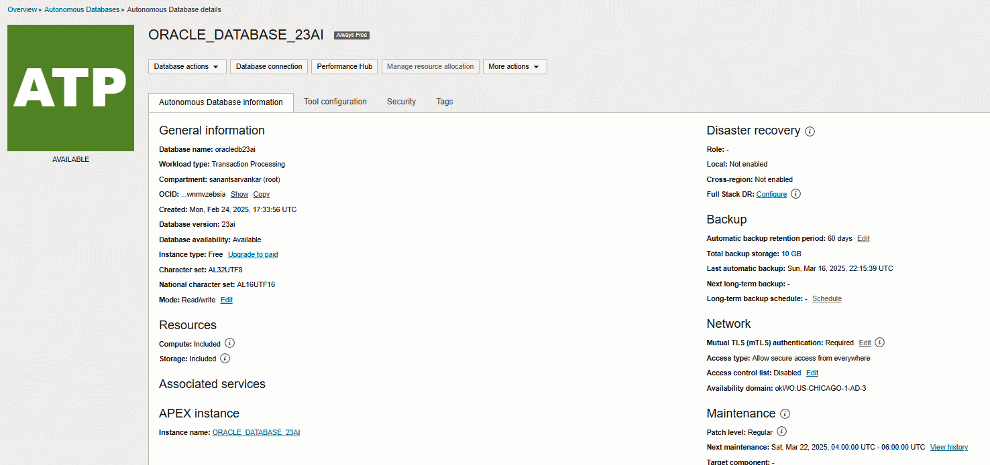
Step 2: Create a Database User
Create a database user for applying Select AI features. Run the following SQL commands to set up the user (On Admin user) :
SET DEFINE OFF;
CREATE USER SELECT_AI_USER IDENTIFIED BY "Oracle##2025AI";
GRANT RESOURCE TO SELECT_AI_USER;
GRANT CREATE SESSION TO SELECT_AI_USER;
GRANT CREATE VIEW TO SELECT_AI_USER;
GRANT CREATE TABLE TO SELECT_AI_USER;
GRANT CONNECT TO SELECT_AI_USER;
GRANT ALTER SYSTEM TO SELECT_AI_USER;
GRANT ALTER USER TO SELECT_AI_USER;
ALTER USER SELECT_AI_USER QUOTA 10M ON temp;
GRANT CONSOLE_DEVELOPER TO SELECT_AI_USER;
GRANT DWROLE TO SELECT_AI_USER;
GRANT EXECUTE ON DBMS_CLOUD TO SELECT_AI_USER;
GRANT EXECUTE ON DBMS_CLOUD_AI TO SELECT_AI_USER;

Step 3: Create a Profile with OCI Generative AI
Different use cases, like where your Autonomous Database is deployed (OCI, Google Cloud or Azure) or how you want to apply AI to your data, may require different models. Select AI lets you choose the right model(s) for that use case. Select AI profiles capture details about your AI provider (OCI Generative AI, Google Gemini, Azure OpenAI, Anthropic, and more) and the tables used for natural language queries. Below, we’ll create a Select AI profile to integrate ADB with Oracle Cloud Infrastructure (OCI) Generative AI. To create a profile:
1. Collect the Required Information
- User OCID: The user’s unique identifier in OCI.
- Tenancy OCID: The tenancy’s unique identifier.
- Fingerprint: The fingerprint of the API key.
- Private Key: Generated when creating the API key.
2. Generate an API Key to collect all details
- Navigate to My Profile > API Key > Add API Key in OCI.
- Download the private and public keys for later use.
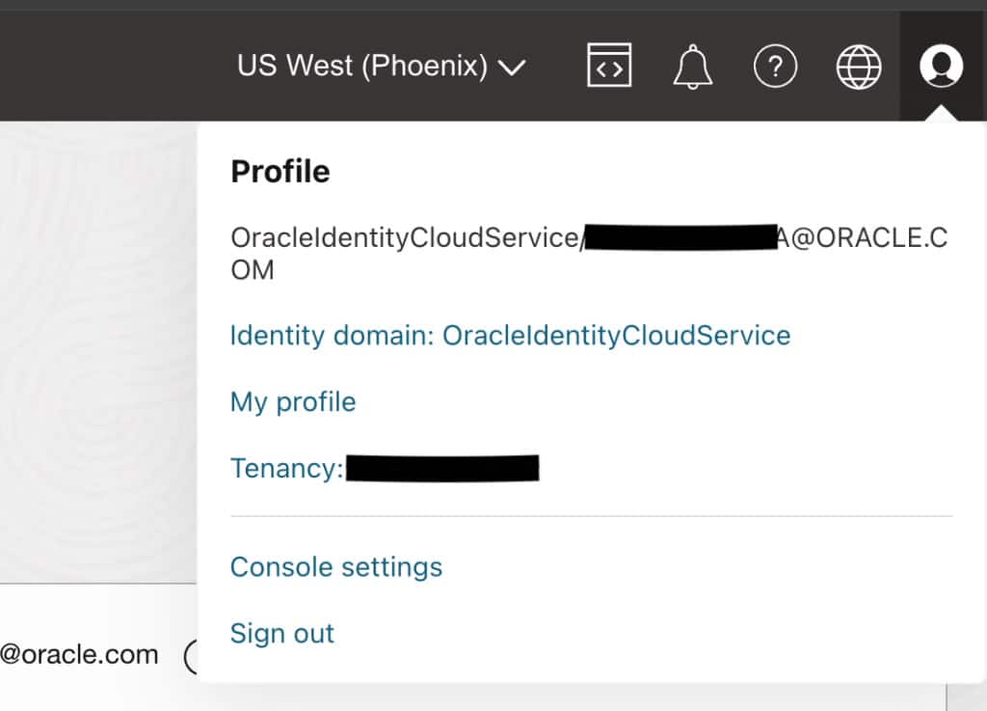
3. Create the Credential
Run the following PL/SQL block to create the credential (On created user - SELECT_AI_USER):
BEGIN
DBMS_CLOUD.create_credential(
credential_name => 'OCI_GENERATIVE_AI_CRED’,
user_ocid => '<UserOCID>',
tenancy_ocid => '<TenancyOCID>',
fingerprint => '<Fingerprint>',
private_key => '<Private Key>'
);
END;
/
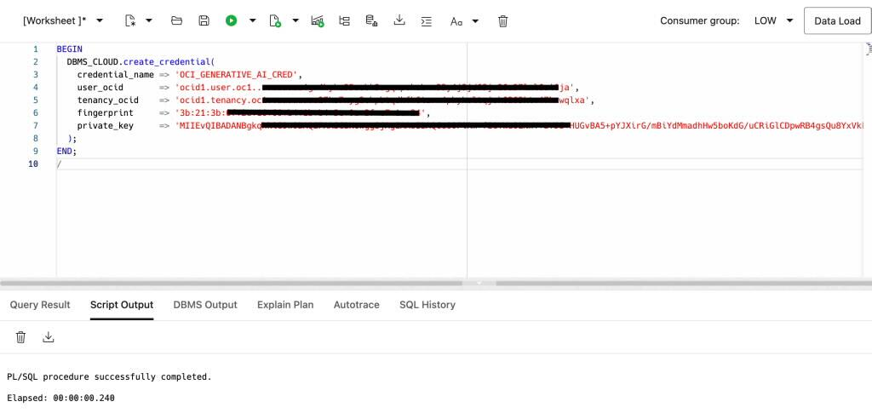

4. Verify the Credential
Execute the following query (On created user - SELECT_AI_USER):
SELECT * FROM DBA_CREDENTIALS;
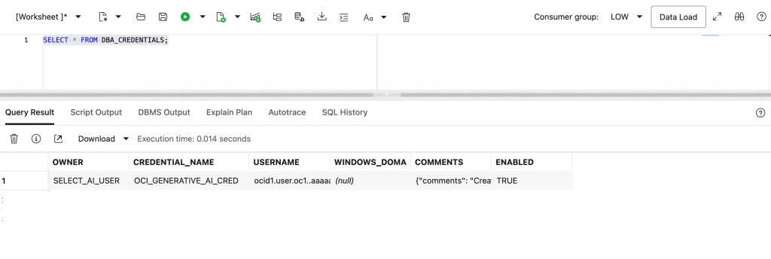
5. Create a Profile Based on the Credential and Referenced Tables
To proceed, you need the compartment ID where your OCI (Oracle Cloud Infrastructure) user has access to Generative AI resources. Use the following PL/SQL block to create the profile (On created user - SELECT_AI_USER):
BEGIN
DBMS_CLOUD_AI.CREATE_PROFILE(
profile_name => 'OCI_GENERATIVE_AI_PROFILE' ,
attributes =>
'{
"provider": "oci",
"region": "us-chicago-1",
"oci_compartment_id": "<CompartmentID>",
"credential_name": "OCI_GENERATIVE_AI_CRED",
"object_list": [
{"owner": "SELECT_AI_USER", "name": "Customers"},
{"owner": "SELECT_AI_USER", "name": "Branches"},
{"owner": "SELECT_AI_USER", "name": "Accounts"},
{"owner": "SELECT_AI_USER", "name": "Transactions"},
{"owner": "SELECT_AI_USER", "name": "Loans"},
{"owner": "SELECT_AI_USER", "name": "LoanPayments"},
{"owner": "SELECT_AI_USER", "name": "Employees"},
{"owner": "SELECT_AI_USER", "name": "Cards"},
{"owner": "SELECT_AI_USER", "name": "Services"},
{"owner": "SELECT_AI_USER", "name": "CustomerServices"}
],
"model": "meta.llama-3.1-70b-instruct"
}');

END;
/
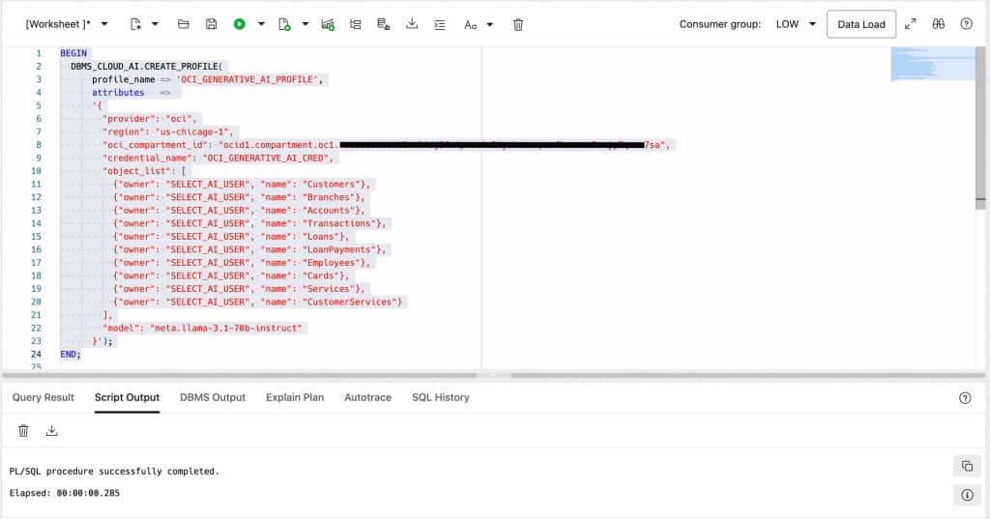
This script defines a profile named OCI_GENERATIVE_AI_PROFILE using the DBMS_CLOUD_AI.CREATE_PROFILE procedure. Ensure that the compartment ID, region, credential name, and object list align with your OCI setup. The profile includes references to specific database tables required for AI operations.
6. Verify the Profile
Execute the following query:
SELECT * FROM USER_CLOUD_AI_PROFILES;
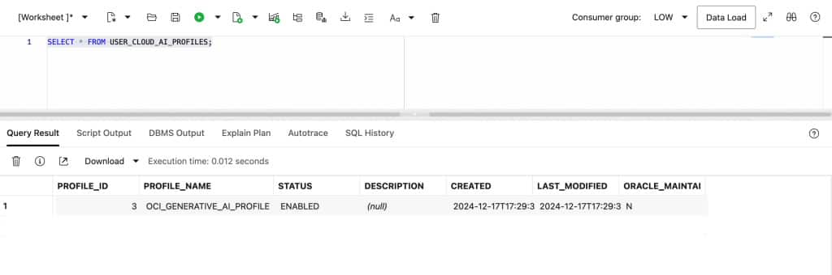
Step 4: Create tables or use cloned tables user ATP DB Admin user

CREATE TABLE ADB_USER.Director (
director_id INT PRIMARY KEY,
name VARCHAR(100)
);
CREATE TABLE ADB_USER.Movie (
movie_id INT PRIMARY KEY,
title VARCHAR(100),
release_date DATE,
genre VARCHAR(50),
director_id INT,
FOREIGN KEY (director_id) REFERENCES ADB_USER.Director(director_id)
);
CREATE TABLE ADB_USER.Actor (
actor_id INT PRIMARY KEY,
name VARCHAR(100)
);
CREATE TABLE ADB_USER.Movie_Actor (
movie_id INT,
actor_id INT,
PRIMARY KEY (movie_id, actor_id),
FOREIGN KEY (movie_id) REFERENCES ADB_USER.Movie(movie_id),
FOREIGN KEY (actor_id) REFERENCES ADB_USER.Actor(actor_id)
);

Step 5: Loging in SELECT_AI_USER DB schema
To verify Created profile.
EXEC DBMS_CLOUD_AI.SET_PROFILE('OCI_GENERATIVE_AI_PROFILE');
SELECT DBMS_CLOUD_AI.get_profile() from dual;
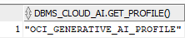

Step 6: Run the API for single table
Select AI introduces a new API, generate_synthetic_data() in the DBMS_CLOUD_AI package, that leverages AI services to generate synthetic data for single tables or a full schema with table dependency relationships. The new API includes two overloaded procedures: one for single table data generation and another for multiple tables.
In the single table case, you specify the AI profile name, the object (table) name, schema owner, and the number of records you want along with an optional user prompt and parameters that further control the data generation.

ssBEGIN
DBMS_CLOUD_AI.GENERATE_SYNTHETIC_DATA(
profile_name => 'OCI_GENERATIVE_AI_PROFILE',
object_list => '[{"owner": "SELECT_AI_USER", "name": "Director","record_count":5},
{"owner": "SELECT_AI_USER", "name": "Movie_Actor","record_count":5},
{"owner": "SELECT_AI_USER", "name": "Actor","record_count":10},
{"owner": "SELECT_AI_USER", "name": "Movie","record_count":5,"user_prompt":"all movies released in 2009"}]'
);
END;
/

View synthetic data: -
select * from SELECT_AI_USER.Movie;
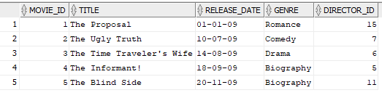

select * from SELECT_AI_USER.Director;
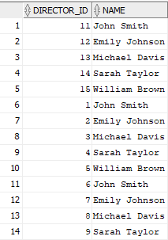
select * from SELECT_AI_USER.Actor;
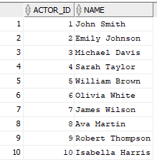
select * from SELECT_AI_USER.Movie_Actor;
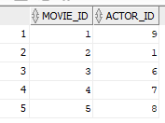

Reference link: -
https://blogs.oracle.com/datawarehousing/post/announcing-select-ai-for-synthetic-data-generation

https://docs.oracle.com/en/cloud/paas/autonomous-database/serverless/adbsb/select-ai-synthetic-data-generation.html

https://docs.public.content.oci.oraclecloud.com/en-us/iaas/autonomous-database-serverless/doc/select-ai-examples.html

